4.4 Relational database systems

- Schema and Instance
- Levels of DB Architecture
- Mapping
- Data Independence
- Data Models
- Hierarchical
- Network
- Relational
- Object Oriented

FATIMA EJAZ BARRI

- Write about schema & instance
Definition of schema: Design of a database is called the schema. Schema is of three types: Physical schema, logical schema and view schema.
For example: In the following diagram, we have a schema that shows the relationship between three tables: Course, Student and Section. The diagram only shows the design of the database, it does not show the data present in those tables. Schema is only a structural view (design) of a database as shown in the diagram below.

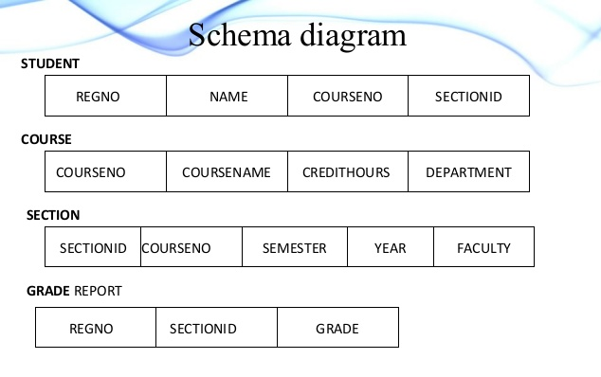

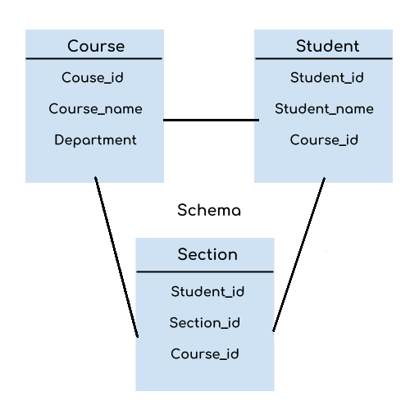
A database schema can be divided broadly into three categories −
- Physical Database Schema − this schema pertains to the actual storage of data and its form of storage like files, indices, etc. It defines how the data will be stored in a secondary storage.
- Logical Database Schema − this schema defines all the logical constraints that need to be applied on the data stored. It defines tables, views, and integrity constraints.
- View database schema- Special view on data used for appraisals.
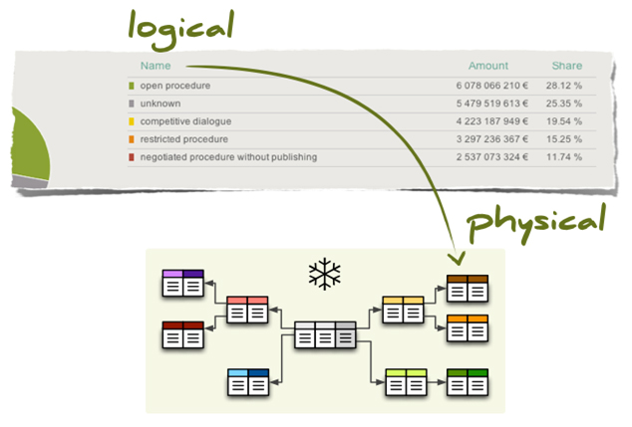

Definition of instance: It is important that we distinguish these two terms individually. Database schema is the skeleton of database. It is designed when the database does not exist at all. Once the database is operational, it is very difficult to make any changes to it. A database schema does not contain any data or information.
A database instance is a state of operational database with data at any given time. It contains a snapshot of the database. Database instances tend to change with time. A DBMS ensures that its every instance (state) is in a valid state, by diligently following all the validations, constraints, and conditions that the database designers have imposed.

Here is a more complex example of a database schema:

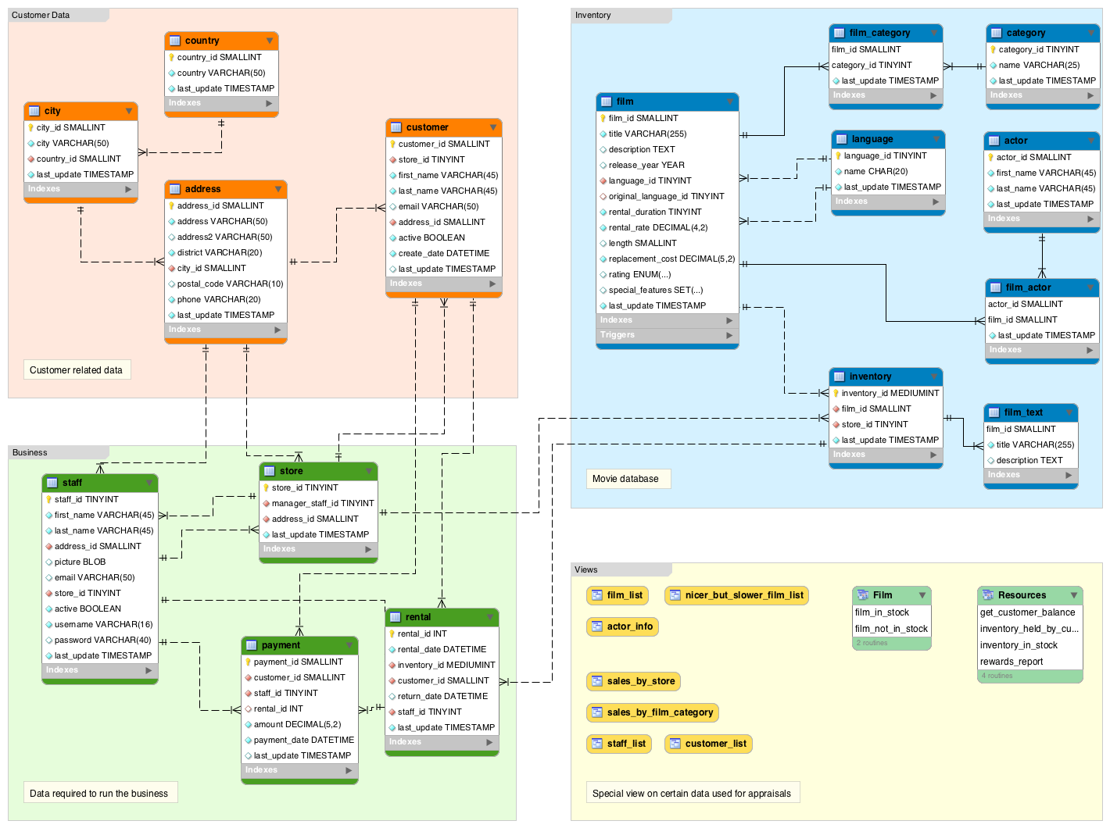

- Levels of DB Architecture

Data Independence
A database system normally contains a lot of data in addition to users’ data. For example, it stores data about data, known as metadata, to locate and retrieve data easily. It is rather difficult to modify or update a set of metadata once it is stored in the database. But as a DBMS expands, it needs to change over time to satisfy the requirements of the users. If the entire data is dependent, it would become a tedious and highly complex job.

Logical Data Independence
Logical data is data about database, that is, it stores information about how data is managed inside. For example, a table (relation) stored in the database and all its constraints, applied on that relation.
Logical data independence is a kind of mechanism, which liberalizes itself from actual data stored on the disk. If we do some changes on table format, it should not change the data residing on the disk.

Physical Data Independence
All the schemas are logical, and the actual data is stored in bit format on the disk. Physical data independence is the power to change the physical data without affecting the schema or logical data.
For example, in case we want to change or upgrade the storage system itself − suppose we want to replace hard disks with SSD, it should not have any impact on the logical data or schemas.

